CS150 Lab5

Oanh Doan

September 28, 2017

1. **Results**

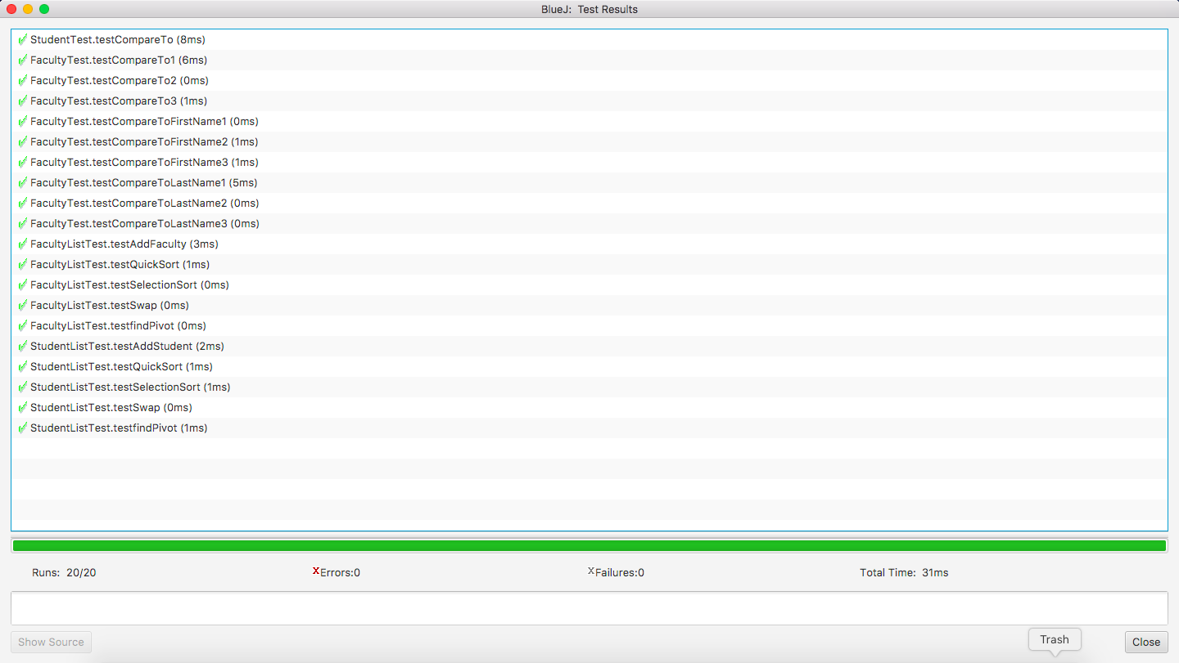

Figure 1. JUnit Testing

|  |  |  |  |  |
| --- | --- | --- | --- | --- |
| **Size** | **Student**  **Quick Sort** | **Student**  **Selection Sort** | **Faculty**  **Quick Sort** | **Faculty**  **Selection Sort** |
| 5 | 108788 | 21194 | 419124 | 37427 |
| 15 | 134715 | 123150 | 2043643 | 371348 |
| 30 | 354699 | 271998 | 2463632 | 1558159 |
| 40 | 372653 | 287062 | 1660762 | 2593648 |
| 50 | 344173 | 523684 | 1709187 | 3582887 |

Table 1. Sort time (nanoseconds)

Figure 2. Sort Time of Student List

Figure 3. Sort Time Of Faculty List

In theory, we expect the complexities of Quick sort (“11.09.01 - Introduction,” n.d.) (“11.09.02 - Partition,” n.d.)and Selection sort (“11.06.01 - Selection Sort,” n.d.) are O(nlogn) and O(n2), respectively. In Figure 2 and Figure 3, we can see that the shape of the graphs seems to match with our complexity expectations. In particular, the growth of Quick sort run time slows down and diverges from Selection sort as the input size increases. However, because of small input sizes, we have not been able to observe a significant difference between Quick sort and Selection sort.

Note that both Quick sort and Selection algorithms are taken from the course’s online textbook. Other materials such as Abstract class(“Abstract Methods and Classes (The JavaTM Tutorials > Learning the Java Language > Interfaces and Inheritance),” n.d.), LinkedList (“LinkedList (Java Platform SE 7 ),” n.d.), and Comparable Interface (“Comparable (Java Platform SE 7 ),” n.d.) are from the API.

1. **References**

11.06.01 - Selection Sort. (n.d.). Retrieved September 10, 2017, from https://canvas.instructure.com/courses/1171720/assignments/6432392?module_item_id=12945299

11.09.01 - Introduction. (n.d.). Retrieved September 29, 2017, from https://canvas.instructure.com/courses/1171720/assignments/6432401?module_item_id=12945321

11.09.02 - Partition. (n.d.). Retrieved September 29, 2017, from https://canvas.instructure.com/courses/1171720/assignments/6432402?module_item_id=12945323

Abstract Methods and Classes (The JavaTM Tutorials > Learning the Java Language > Interfaces and Inheritance). (n.d.). Retrieved September 29, 2017, from https://docs.oracle.com/javase/tutorial/java/IandI/abstract.html

Comparable (Java Platform SE 7 ). (n.d.). Retrieved September 29, 2017, from https://docs.oracle.com/javase/7/docs/api/java/lang/Comparable.html

LinkedList (Java Platform SE 7 ). (n.d.). Retrieved September 17, 2017, from https://docs.oracle.com/javase/7/docs/api/java/util/LinkedList.html